SNAG PREDICTION OF AIRCRAFT COMPONENTS

# Introduction

Reliability and availability of aircraft components have always been an important consideration in aviation. Accurate prediction of possible failures will increase the reliability of aircraft components and systems. The scheduling of maintenance operations help to determine the overall maintenance and overhaul costs of aircraft components. Maintenance costs constitute a significant portion of the total operating expenditure of aircraft systems.

There are three main types of maintenance for equipment: corrective maintenance, preventive maintenance, and predictive maintenance. Corrective maintenance helps manage repair actions and unscheduled fault events, such as equipment and machine failures. When aircraft equipment fails while it is in use, it is repaired or replaced. Preventive maintenance can reduce the need for unplanned repair operations. It is implemented by periodic maintenance to avoid equipment failures or machinery breakdowns. Tasks for this type of maintenance are planned to prevent unexpected downtime and breakdown events that would lead to repair operations. Predictive maintenance, as the name suggests, uses some parameters which are measured while the equipment is in operation to guess when failures might happen. It intends to interfere with the system before faults occur and help reduce the number of unexpected failures by providing the maintenance personnel with more reliable scheduling options for preventive maintenance. Assessing system reliability is important to choose the right maintenance strategy.

Machine learning is a rising technology that is supposed to develop in the future. Machine learning methods are applied in prediction/preventive systems, communications, security, energy management, and so on. It manages the data to make it useful for decision. The decision making depends on future forecasting, failure event, and availability of equipment. Data mining is a way of classifying and clamping data into comprehensible information. It comprehends the applicable models from a mass of information and adopts different approaches to uncover secret data.

This paper discusses the feature selection of variables in the maintenance data obtained from Aircraft Maintenance firm. The proposed system will help companies to collect, extract, and create data to improve the maintenance actions through more accurate predictions. This study proposes a hybrid data preparation method for maintenance data and predicting failure counts of equipment by comparing the results of three different algorithms.

# Flow Logic

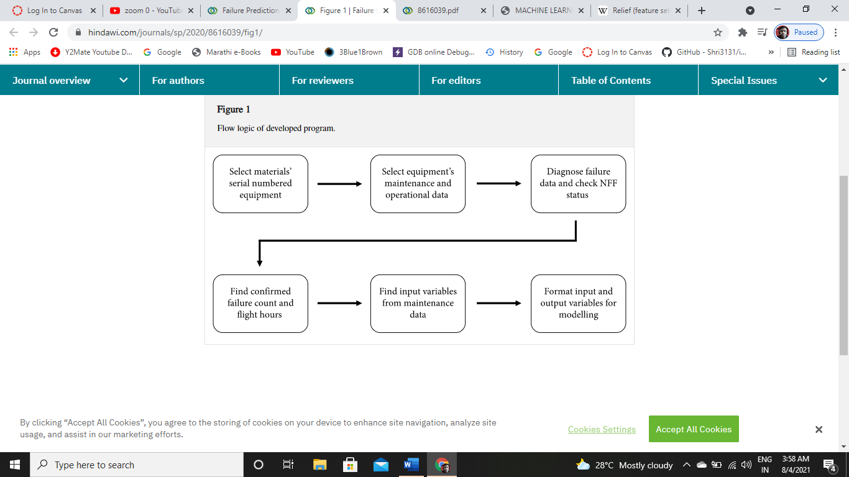

# Tools

- ReliefF Algorithm is used for selecting attributes

- *K*-means algorithm is used to eliminate the redundant data.

- Three methods for predicting equipment failure counts are introduced and compared using MLP as an ANN algorithm, SVR algorithm, and LR.

# Data collection and preprocessing & EDP

Data collected from technical section of the maintenance crew. ReliefF is an extension of the Relief algorithm, which fails to remove irrelevant or incomplete features in two-class classification problems. The ReliefF algorithm finds one near miss for each different class and averages their value to revise feature weights.

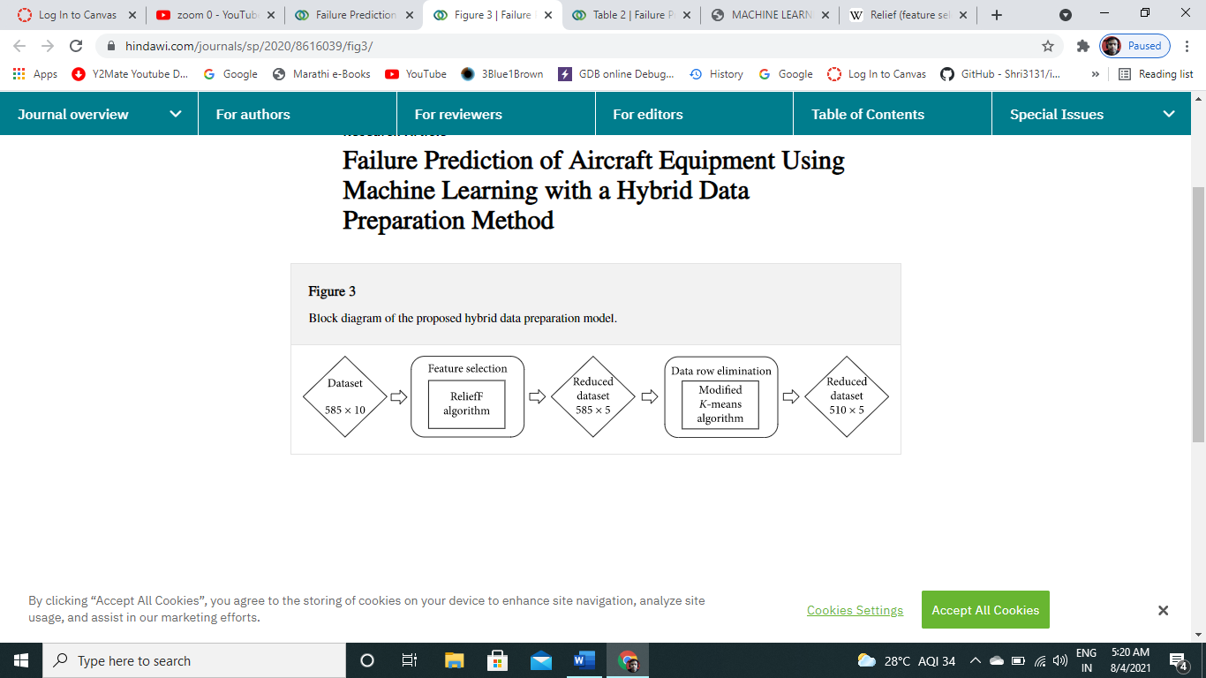

The input variables/factors are operational and environmental parameters which could influence failure occurrence and the length of operation before failures occur. Input variables include such parameters as flight hours, the number of removals of equipment, and the number of faults with planned/unplanned removals. These data were analysed and represented in a format suitable for modelling, and variables were characterised with the corresponding domain classification.

To eliminate noisy and irrelevant data K-means algorithm is used which is less time consuming and more efficient clustering algorithm.

# Data Insights

FH- Flight Hours.

RM- The no of removal of eqpt in last 24 months.

PR- The no of planned removal.

UR- The no of unplanned removal.

OR- The no of other removal eqpt.

FR- The no of fault with removal of eqpt.

FPR- The no of faults with planned removal.

FUR- The no of faults with unplanned removal.

SR- The no of safe removal of eqpt.

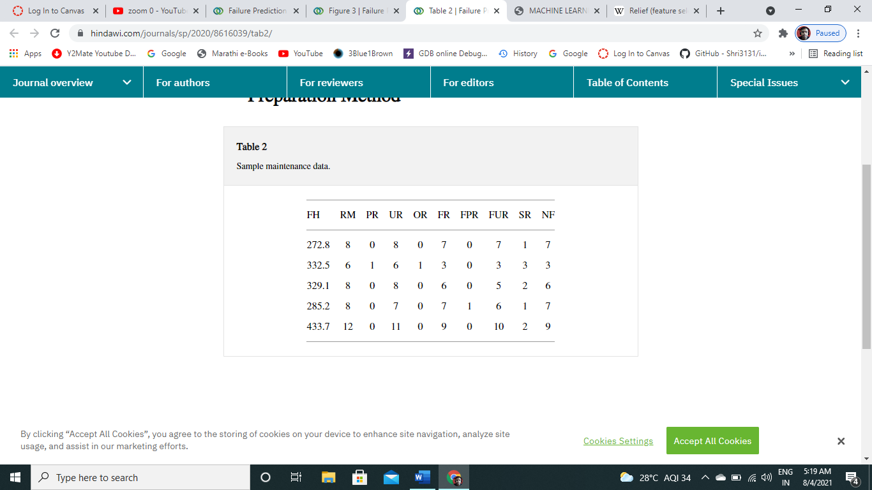

# Experimental result

A program is developed to gather data for analysis through machine algorithms. Selected equipment’s maintenance and operational data were identified. Nine input variables and an output variable were determined. According to using pure 585 rows, nine inputs, and an output (585 × 10) data, MLP, LR, and SVR models were trained and tested.

# To illustrate the performance of the suggested two-phase hybrid system, the prediction results for the raw dataset that is composed of 585 records and 9 attributes are presented. The best results were provided by the SVR algorithm, while the LR algorithm provided the best results based on the MAE and RMSE performance criteria.

# Conclusion

In aviation, the use of maintenance data is highly critical in the analysis of reliability and maintenance costs. This is because predictive maintenance scheduling can be planned in line with estimates. The main target of predictive maintenance is to predict equipment failures and planning strategies for spare parts of the system components to analyze the reliability and maintainability of a complex repairable system. In this study, a hybrid data preparation model was applied to the landing gear system maintenance dataset using feature selection ReliefF algorithm to select attributes and a *K*-means algorithm to eliminate noisy and inconsistent data. The proposed hybrid data preparation method was put into practice through LR, SVR, and MLP models. The results indicated that the LR model had better performance than MLP and SVR models in predicting the failure counts. The results indicate that the proposed hybrid data preparation model significantly improves the accurate prediction of failure counts.